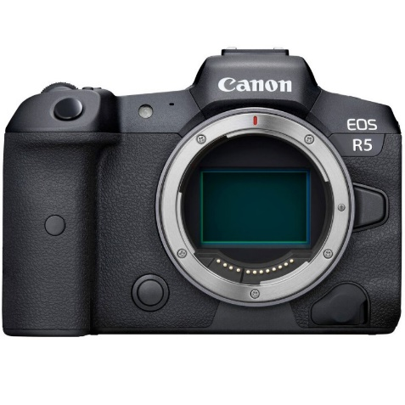



Canon EOS R5 Mirror less Digital Camera (Body Only)

₨.666,900

Description:

Canon EOS R5 Mirror less Digital Camera (Body Only) Price & Specs
- Newly Developed Full-Frame CMOS Sensor
- 8K30 Raw and 4K120 10-Bit Internal Video
- In-Body 5-Axis Image Stabilization
- 12 fps Mech. Shutter, 20 fps E. Shutter
- Rs.666,900
Canon EOS R5 Mirror less Digital Camera (Body Only)
Canon r5 price in Pakistan makes it worth buying this year. The camera is nothing short of a masterpiece released by the canon. The company designed a new CMOS sensor for EOS R5. The quality of images is the center of attraction for photographers. It was introduced to set new standards for image and video content.
This mirror less camera can capture moving object with a speed burst. You can use 12fps with mechanical shutter and 20fps with silent shutter. The detail result of the EOS R5 is beyond anything ever release in this category. The Canon R5 in Pakistan helps you detect more precisely.
The subject detection and adaptation is easy. The high speed AF matches the powerful 20 fps shooting capabilities like a piece of cake. The AF comes with face, head, and eye tracking capabilities that are hard to find in cameras these days. Canon r5 price in Pakistan is nothing in front of the enormous features that it possesses.
Some distinct features of this camera include 8K raw and 4k 120p shooting. In body stabilization, dual card slots, dual pixel, canon cloud, and much more. The breath taking quality it produces is beyond anything that you have seen in this category.
Canon is currently developing the EOS R5 full-frame mirror less camera containing CMOS sensor, image processing, optical, and other state-of-the-art technologies the company has cultivated through its long history of camera development. The EOS R System enables greater freedom in lens design thanks to a wider lens mount diameter, short back focus, and high-speed system for transmitting data between the camera and lens, resulting in an imaging system that delivers higher image quality and greater ease-of-use.
The new full-frame mirror less camera, currently under development, will fully leverage the advantages of the EOS R System, helping to produce a camera that features high-speed continuous shooting and 8K video recording. Furthermore, the camera will provide photographers with more efficient workflows thanks to improved transmission functionality, operability and reliability. These enhancements, along with many others, will help to further elevate and solidify the EOS Series concept of "Speed, Comfort and High-Image-Quality."
Canon's EOS R5, the first of the next generation of full-frame mirror less cameras planned for EOS R System, will include a newly developed CMOS sensor. The new sensor will enable enhanced features such as high-speed continuous shooting up to approximately 20 fps when using the silent shutter and up to approximately 12 fps when using the mechanical shutter; a feature professional sports and wildlife photographers will find to be extremely impactful on their ability to capture fast-moving subjects. From a video perspective, the camera's 8K video capture capability will prepare videographers for the future of movie-making: capturing 8K footage today allows for even higher-quality 4K productions in addition to the ability to extract high-resolution still images from the video footage. The EOS R5 will be the first Canon camera equipped with IBIS (In Body Image Stabilization) and when used in conjunction with the extremely effective in-lens stabilization (IS), will allow photographers to handhold the camera in light levels not previously imagined. Additionally, the camera will also feature dual-card slots and will support the automatic transfer of image files from the device to the new image. Canon cloud platform.
Advanced Full-Frame CMOS Sensor
Canon has developed an entirely new CMOS image sensor for the EOS R5. Image quality is at the heart of the EOS R System and the EOS R5 is set to raise the bar in high level still and video capture empowered by this new CMOS sensor and the new DIGIC processor.
High-Speed Shooting up to 20 fps
The EOS R5 can capture fast moving subjects in high speed burst. At up to 12 fps with mechanical shutter and up to 20 fps with silent shutter, the EOS R5 can capture the split-second details between a subject's movements.
Autofocus and Subject Detection
Utilizing Canon's Dual Pixel CMOS AF Technology, the EOS R5 will be capable of making ultra-high-speed autofocus calculations to match its immensely powerful high-speed shooting capability of 20 fps. Subject detection adopted from the Live View AF tracking system in the EOS-1D X Mark III brings Face, Head and even Eye tracking when People detection is set, providing ease and accuracy when capturing stills or video. Detection of Animals will also be possible for the first time in a Canon camera, effectively tracking the whole body, face, or eye of cats, dogs, or birds for speed and precision.
Larger Than Life 8K Video
Canon revolutionized the video industry with the introduction of the EOS 5D Mark II, which provided solutions for what was previously seen as improbable. The EOS R5 will again push the boundaries of what filmmakers can do compared to current DSLR and mirror less cameras. With Internal, uncropped 8K video shooting at up to 29.97 fps, and 4K video shooting at up to 119.9 fps, in 4:2:2 10-bit (H.265) Canon Log, and Dual Pixel CMOS AF available in all 8K and 4K modes, image makers worldwide will be able to tell their stories in larger-than-life resolutions. Additional new features include: Internally recorded and uncropped 8K Raw recording, up to 29.97 fps with Dual Pixel CMOS AF, and HDR-PQ Recording (H.265) capability.

In-Body Image Stabilization
Canon's first camera to incorporate 5-axis IBIS (In-Body Image Stabilization), the EOS R5 will not only enhance the ability to shoot still images at slower shutter speeds but it will also help reduce camera shake when shooting movies. Additionally, the EOS R5's IBIS will work in combination with Optical Image Stabilization found in many Canon RF and EF lenses.
Dual Card Slots
Whether you are recording everyday images, an important photo shoot or recording 8K video, a super high-speed CF express card slot plus a UHS-II SD card slot are at your disposal.
Convenience in a Cloud
With the creative process being just as important as image capture, the EOS R5 will support automatic transfer of still image and video files from the device to the new image. Canon cloud platform. New workflows will be possible through the automatic download and backup of data to your Mac/PC, or automatic transfer of data to external services such as Google Drive and Flickr.

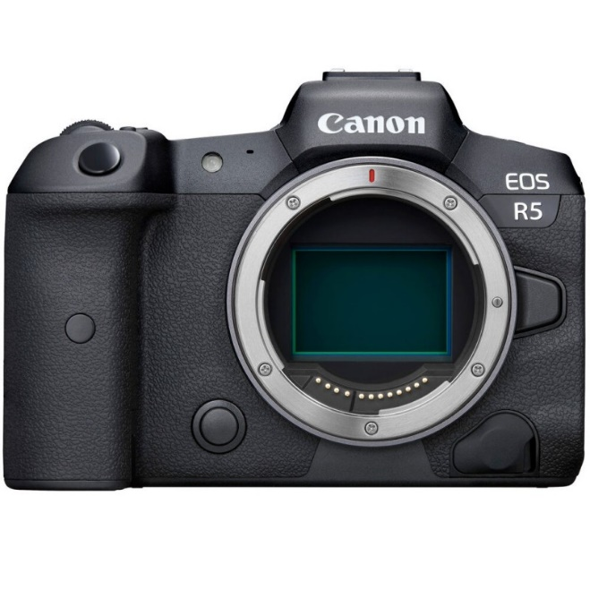
Pictuers:
